Carriage Control

Objective: The bandits raid the carriage. The guard protects the carriage. The Bandits need to steal all the carriage’s riches. The guard need to protect the carriage to the end of its journey.

Setting: A small map with a path down the middle where the carriage travels to its destination. Bandits will spawn on the mountainous side of the map. Guards will spawn near the carriage. The Bandits side will be unarmed but will have speed on their side. The players have guns with limited ammunition.

Gameplay: The players perspective will be in first person.

Rules:

1. The player will play as a guard and have limited ammo for the duration of the game.
2. The player must eliminate the bandits to prevent them from stealing gold.
   1. If a bandit dies with gold on them it is spawn back to the carriage.
3. The player may also follow the Bandits to their hideout and steal the gold back.
   1. If a player steals gold from the bandits they must return it to the cart in order for it to count as part of the guards gold amount.
4. Once the carriage reaches its destination the winner is determined by which side has more gold.

Start Game Instructions

Unzip the Bandits and Builders Folder

Double click on the Application named Janosik.

Controls:

Mouse movement aims the weapon and changes players view.

W,A,S,D to move the player

Left-click ok mouse to fire the gun.

Mouse Wheel

Scroll up: Zoom in

Scroll down: Zoom Out

R to reload the weapon

E is the use button for when player is prompted to steal from the bandits.

Map:

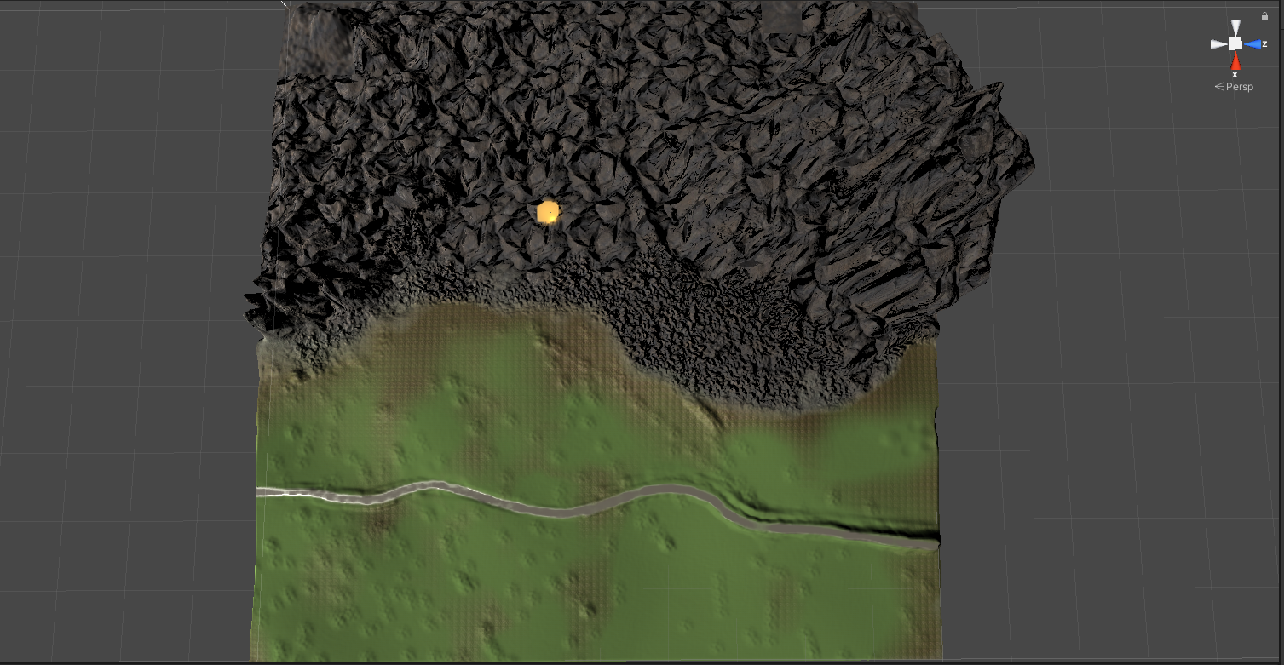

Player Models

* Player
  + 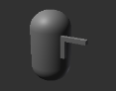
* Bandit
  + 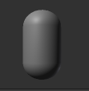
* Carriage
  + 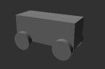

Game Window:

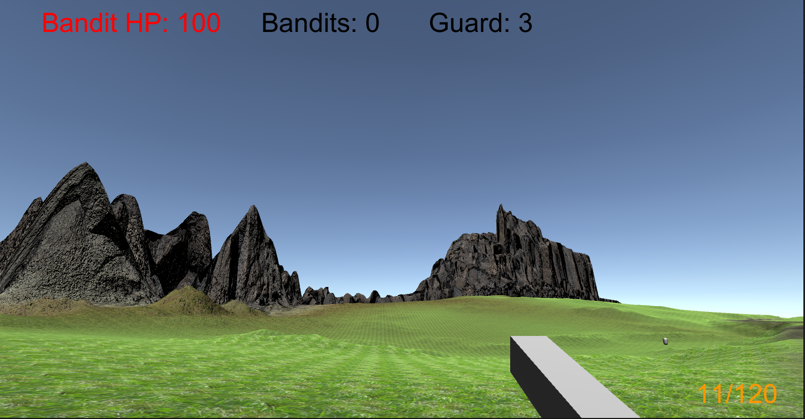

* Top right corner: Indicates Bandits Health
* Upper Middle: How much gold the Bandits and Guards have.
* Bottom Right: The current amount of ammo in the gun/ The remainder of ammo the player has.

Additional Windows:

There is also a main menu screen and the rending results screen. Apart from the ending screen giving player results of the game they both have buttons to allow the player to play the main game or quit the application.

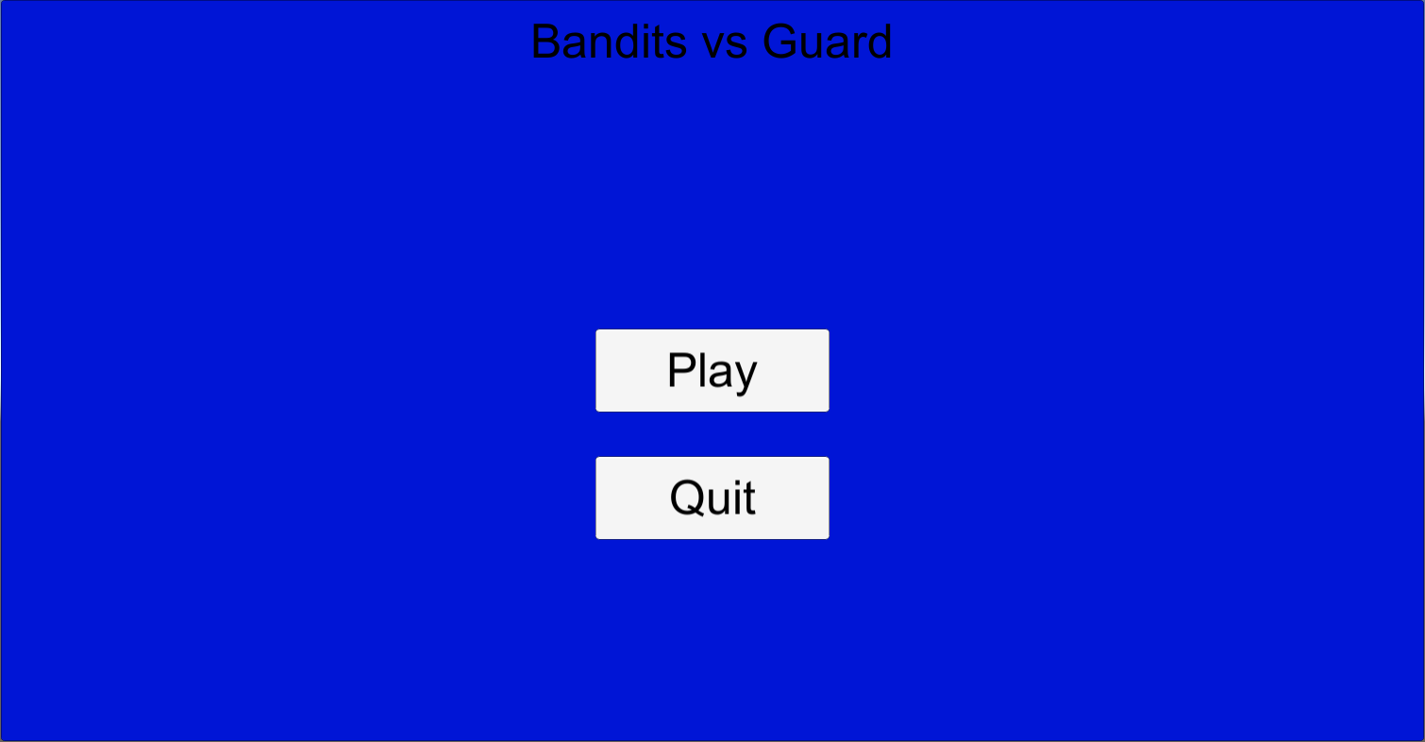

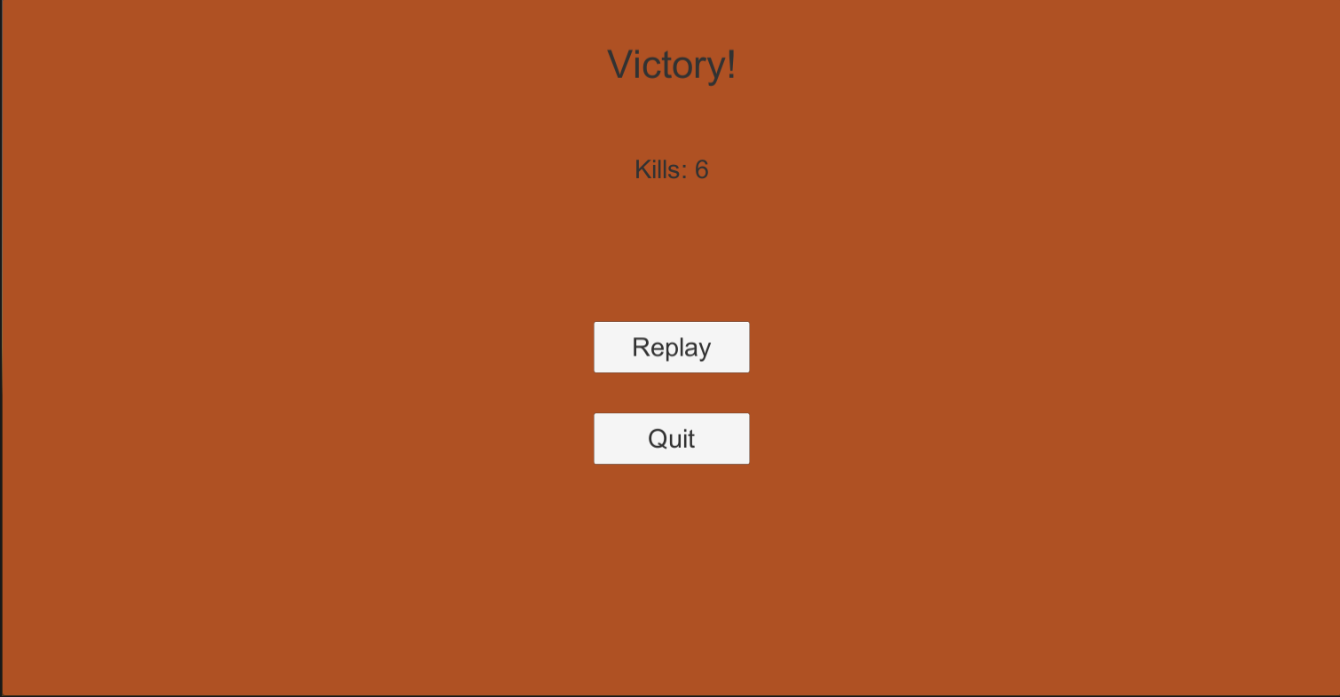

User Case:

Once I had a stable build of the game, I asked a friend to play a match from me and give me some feedbacks. My friend said that the game was easy enough and to understand but the aiming mechanism was so very intuitive and took time to get used to. The enemies did not really react to the player and made it easy to shoot. At the end he noted that it was nice to have a status like how many bandits he killed but said that without a high score it did not matter to him as much. In hindsight the game I set out to create on my own was more than I could handle. However, this current build does provide a great foundation to work upon for another iteration.

Journey:

* Started with a Unity build and focused on a small terrain.
* Use of simple textures to show flat/grassland and more elevated regions was used.
* The Player and bandit characters are based of First-Person prefabs from Unity that I modified to satisfy the game requirements.
* A lot of time was focused on getting the carriage to follow a progenerated path.
* After this it was easier to create a script for the Bandit to follow the carriage.
* A created a gun Prefab that I attached to the player and began working on projectile behavior.
* Many play tests occurred to fine tune the collision between the player’s projectiles and bandit to make sure every bullet that hit the bandits registered.

Self – Critiques

* Terrain is too simple, and the elevation does not add much to the Gameplay
* Bandit movement path to predictable and make it easy to hit.
* The aiming mechanism is not great and next iteration of the game will approach it differently.

Assets used:

Cobblestone Texture – Tileable

LeanTween

Mini first person controller

Nature Materials vol.1

Terrain Tools Sample Asset Pack

Variable Weathered Cobblestone Substance